# README. Document for Meal-Plan Application.

The Read-Me file is meant to guide for an end user to use when wanting to run the program letting them know what’s needed to run the program.

Below it shows all the look of the app on Android Studio:

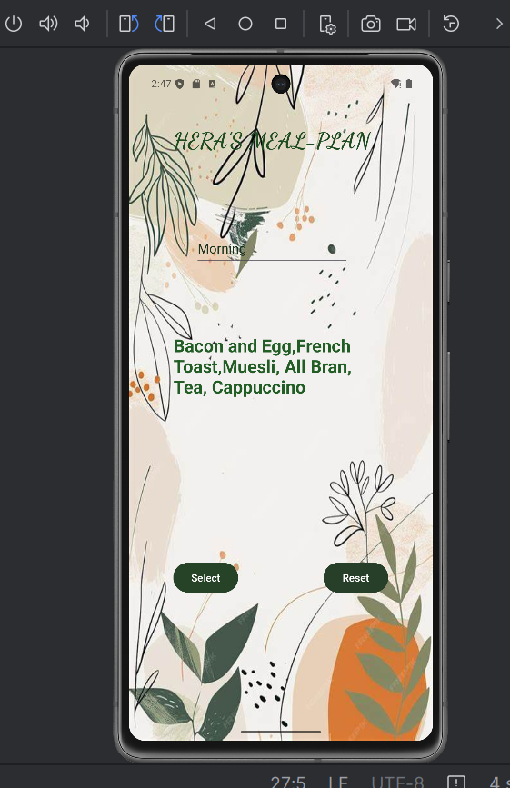

Below shows how the application looks on the activity main:

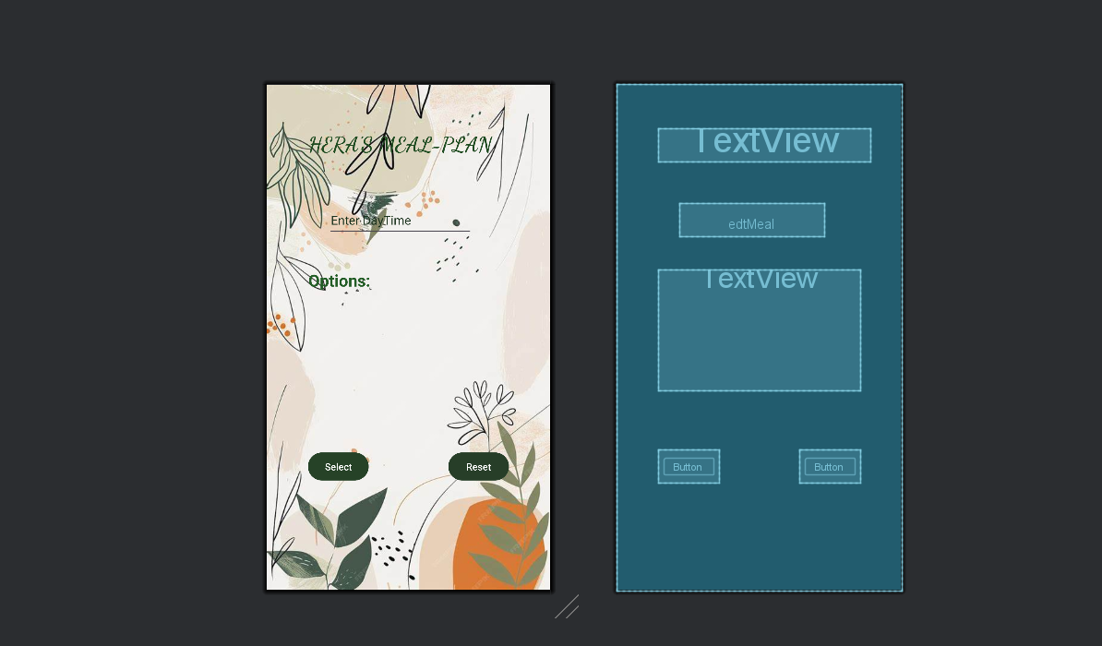

Below it shows the coded declarations:

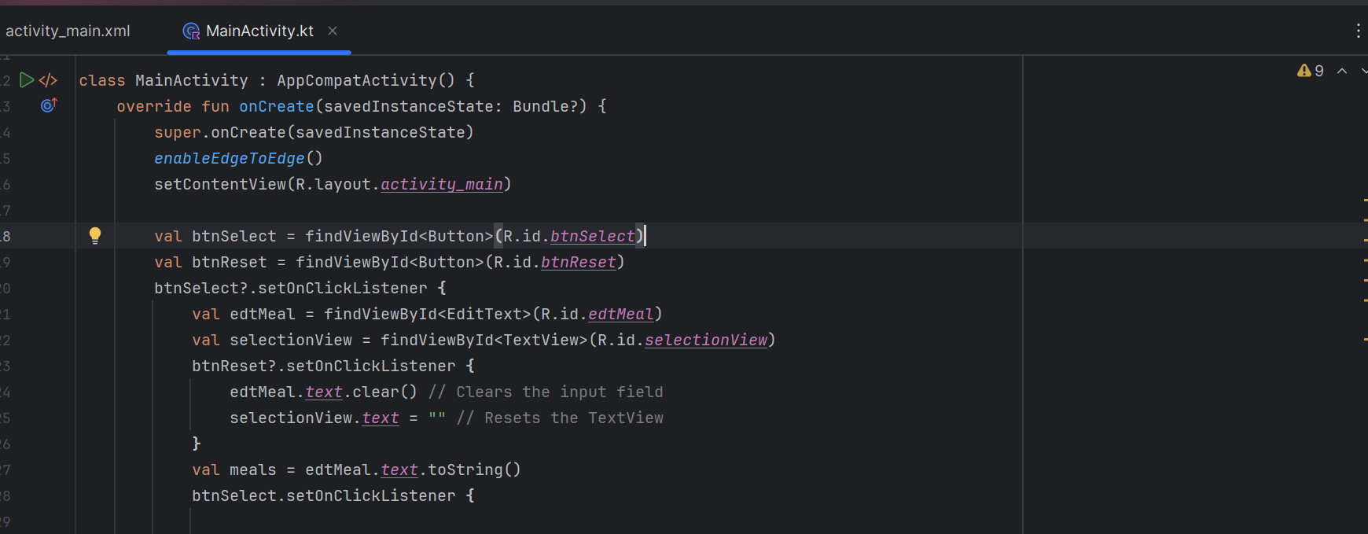

Below it shows the code:

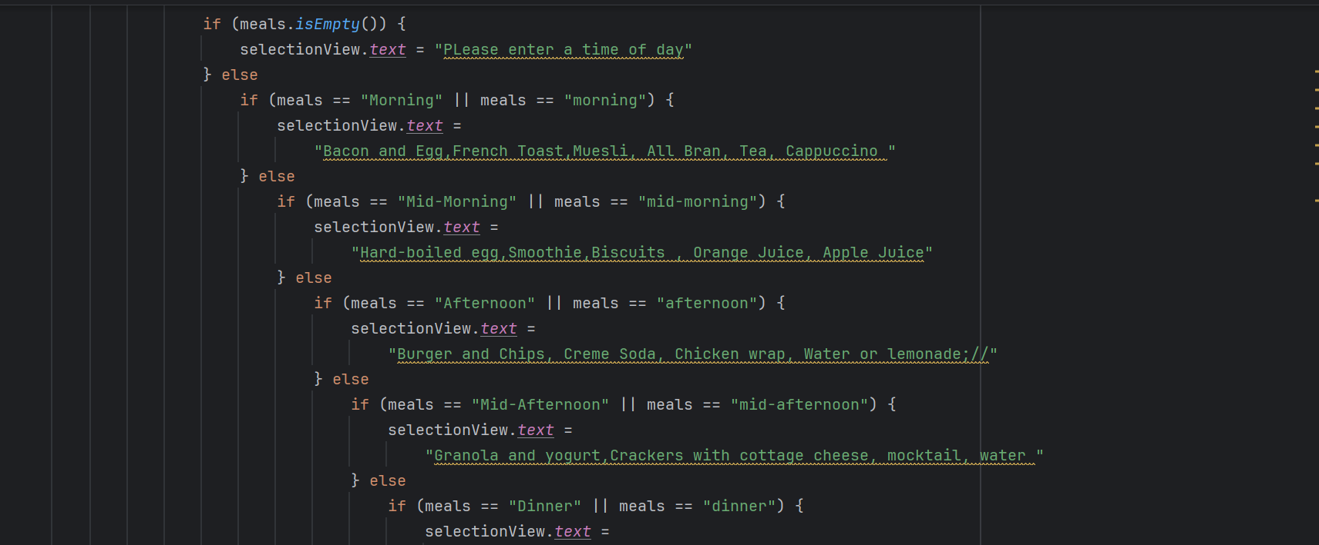

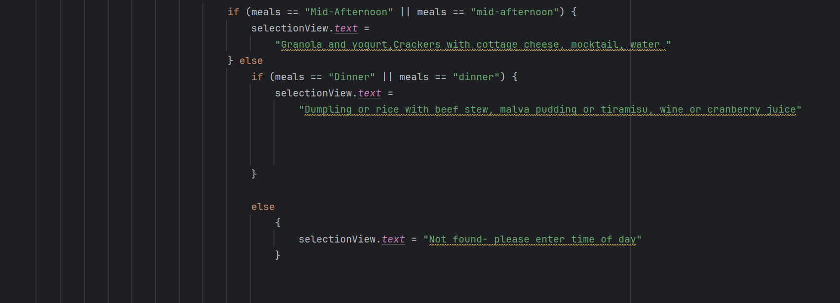

# REPORT:

I have developed an app that provides meal suggestions based on the time of day. The user must input the time of day. User inputs Morning, Mid-morning, Afternoon, Mid-afternoon, Dinner. It will just give meal suggestions based on the time-of-day input. The application accounts for whether the user input time of day with caps or no caps. It has a few options depending on whether the user wants to have something greasy or something rather light. This is easier because you can easily play inky-pinky-ponk-kie on what the user would enjoy based on their taste buds that day. Although it is restricted, it does still give the user a choice based off what they feel like.

READ ME!

1. Environment
2. IDE: Android Studio
3. Language: Kotlin
4. Configuration:
5. Install and open Android Studio
6. Download/drop and drop project files on the local machine.
7. Open android studio
8. Drag and drop/import downloaded project files on Android Studio
9. Run the project in the emulator or virtual devices in Android Studio
10. How to run your emulator:
11. Start BlueStacks
12. Click on the gear icon to open the settings
13. Look for Advanced
14. You find enable ADB (Android Debug Bridge)
15. You will see the port number, take note of it. It is normally 5555 or 5554
16. Double-click on the emulator script on your desktop (it has two little gears on it)
17. Enter your port number to connect to emulator to ADB.
18. You can open Android Studio/Visual Studio code, start coding and running your open app.

Enjoy 😉

Link to the YouTube video: https://youtu.be/IggWsZQEUtM

# REFERENCES:

* www.youtube.com. (n.d.). *Android Studio : How to Add a Background Image to Activity*. [online] Available at: <https://www.youtube.com/watch?v=7OvsWwbvYsM>.
* ‌SHARIF'S CODE CORNER (2025). *🔥 How to design Professional GitHub README.md | Step-By-Step Tutorial for Beginners 🚀*. [online] YouTube. Available at: <https://www.youtube.com/watch?v=lGis0HC6C20> [Accessed 2 Apr. 2025].
* ‌Jeffrey McLeod (2021). *Generating a ReadME.MD file for your projects.* [online] YouTube. Available at: <https://www.youtube.com/watch?v=qJFaXBKVyac> [Accessed 2 Apr. 2025].
* ‌GlobalTechFix (2024). *How To Create README File For GitHub | Make README.md File To GitHub Repository*. [online] YouTube. Available at: <https://www.youtube.com/watch?v=HKdhiOp2uVA> [Accessed 2 Apr. 2025].
* ‌Coding With Evan (2022). *Make a Food Recipe App | Android Project | Full Tutorial Part - 1*. [online] YouTube. Available at: <https://www.youtube.com/watch?v=6-891CSz6v0> [Accessed 31 Mar. 2025].
* ‌Coding Bunch (2022). *Food Recipe App Kotlin | Splash Screen | Android Studio | Part 1*. [online] YouTube. Available at: <https://www.youtube.com/watch?v=dViNgBcuXT4> [Accessed 31 Mar. 2025].